palm house bulletin
  - Volume 5/Issue 5/November 2019
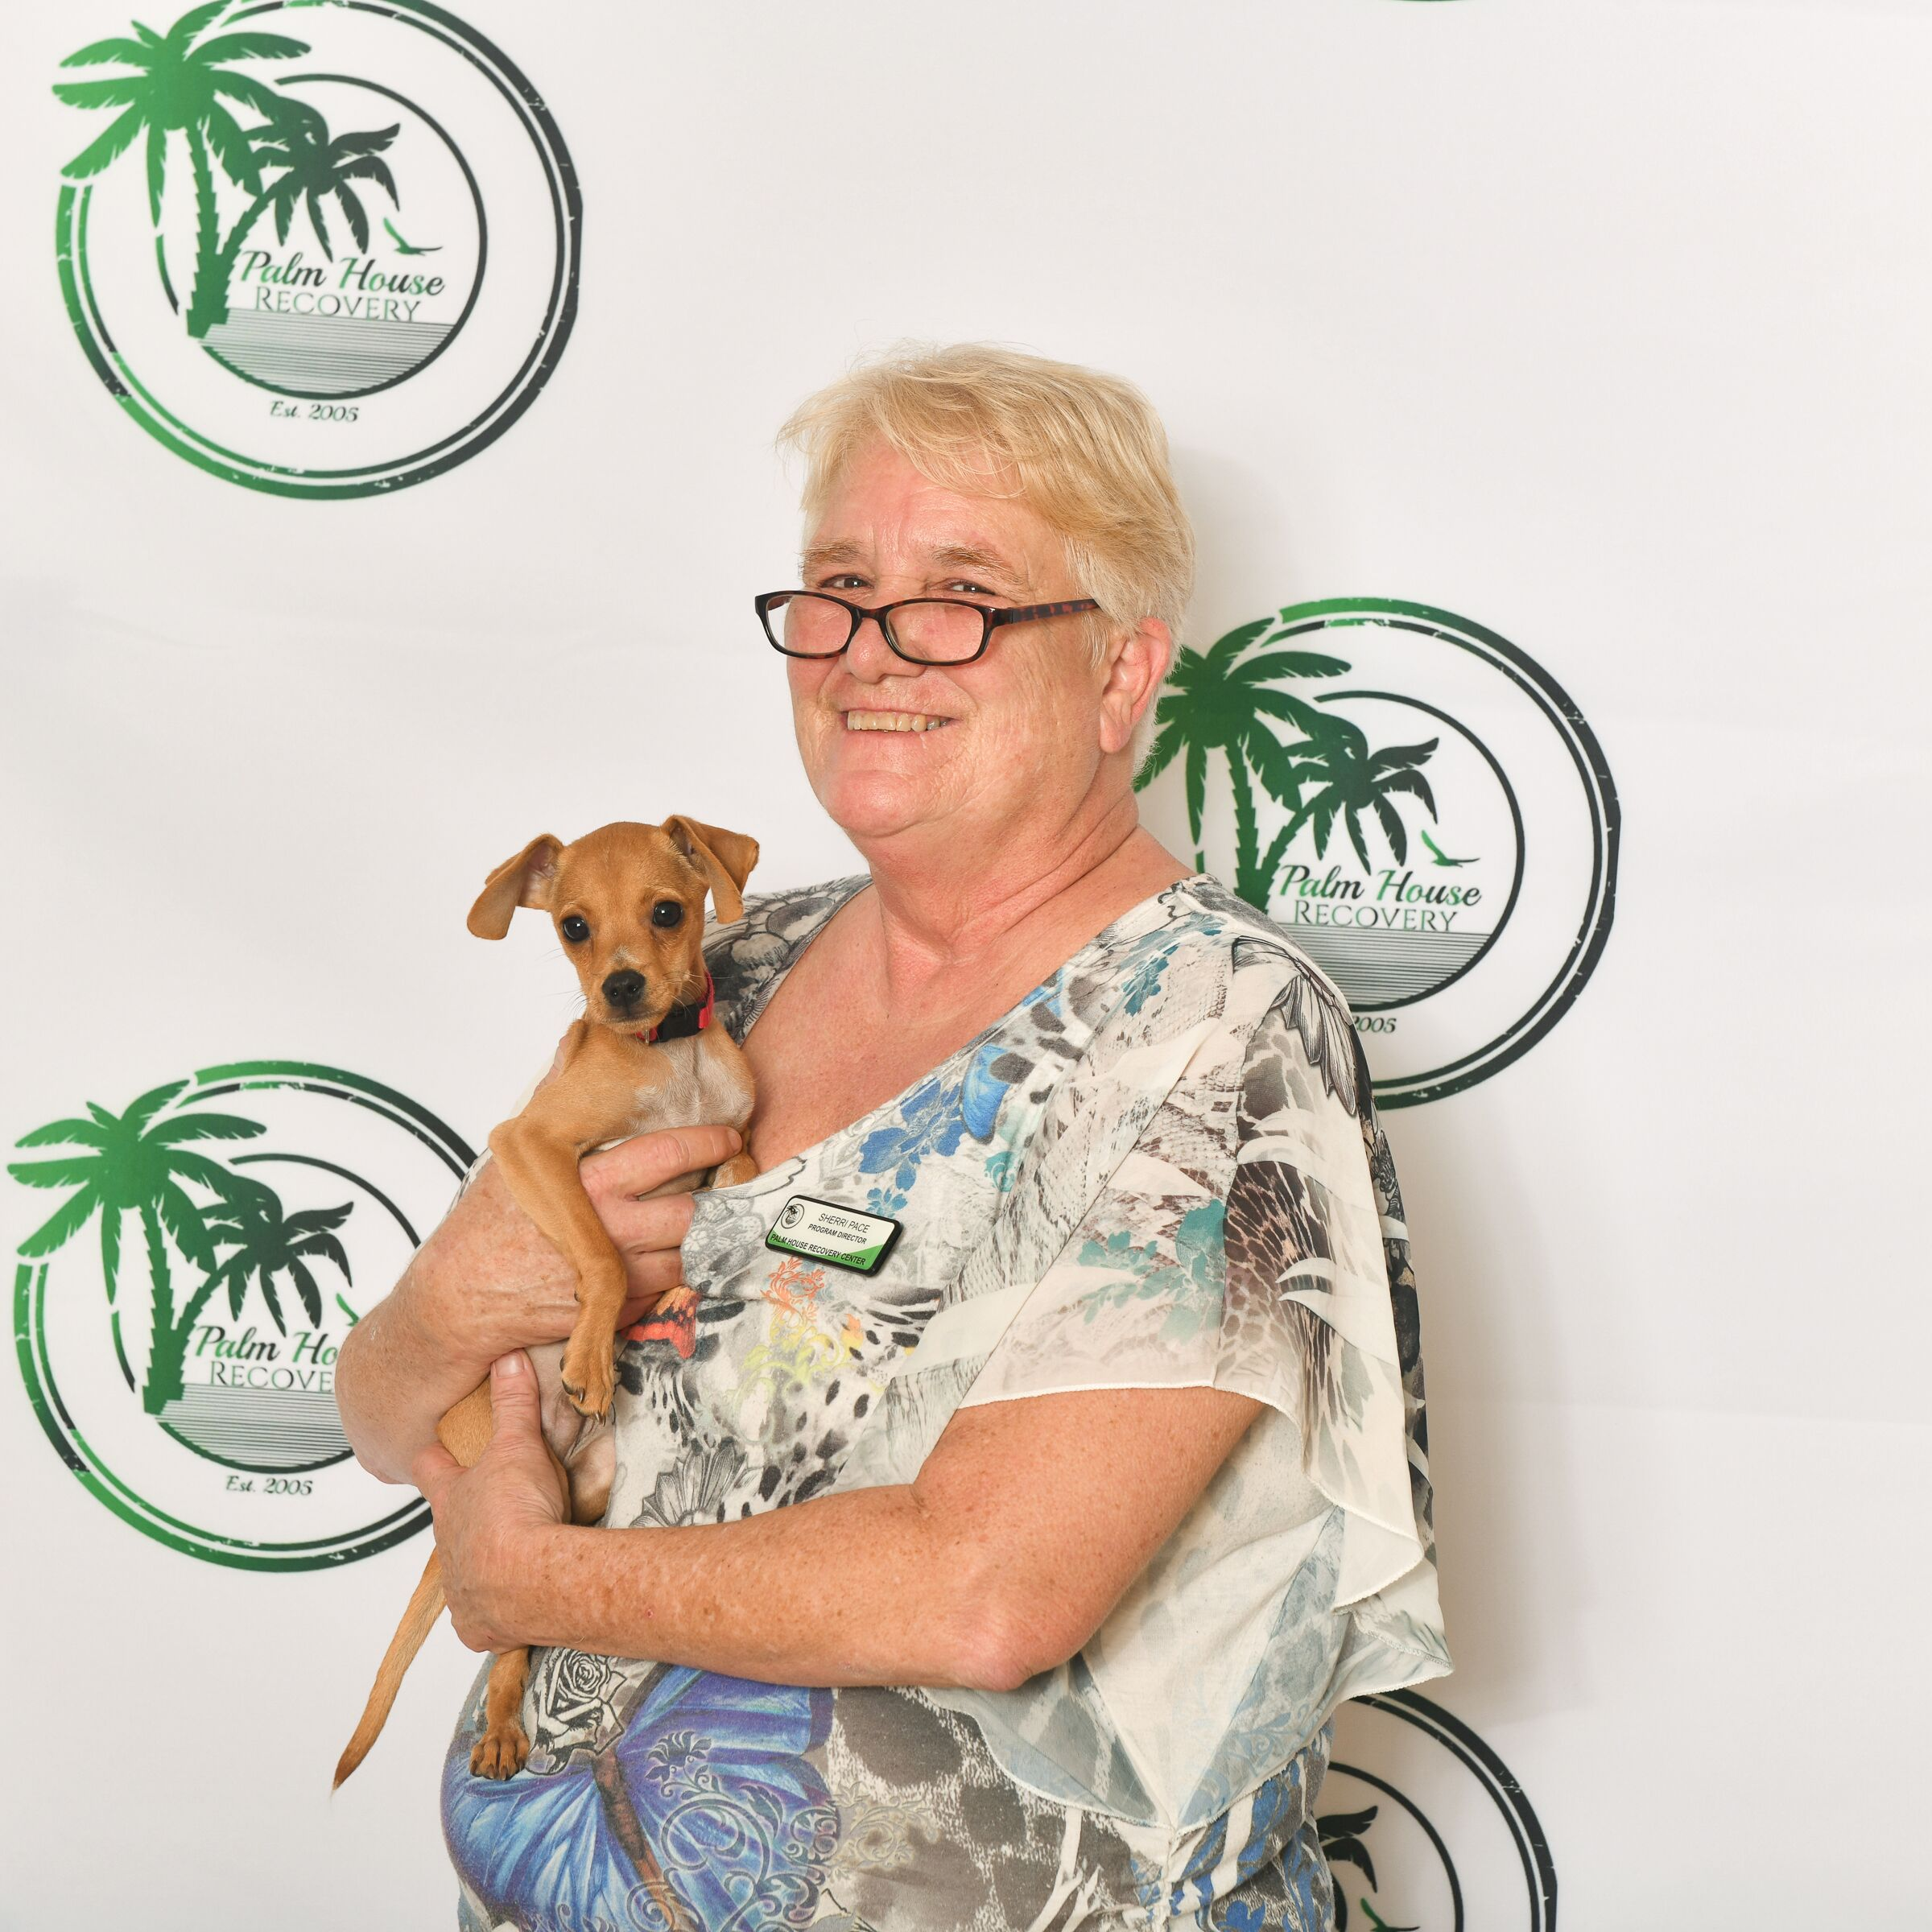
  - A note from Ms. Sherri…
  - Thanksgiving Day is almost here! This is a time to join together with friends and family and give thanks. While the holidays are a special time, for those in recovery it can also be a trying time, with a high likelihood of one’s recovery being put to the test. My hope for you is that you will approach this season with all of the tools you need to have a safe, clean & sober holiday. Thanksgiving can be particularly meaningful to families who are getting another chance to be together. If you are celebrating Thanksgiving in recovery, be grateful for this second chance, not only on your own behalf, but also understand how important it is to the people that love you. Happy Holidays!

  - COMPLETION CORNER
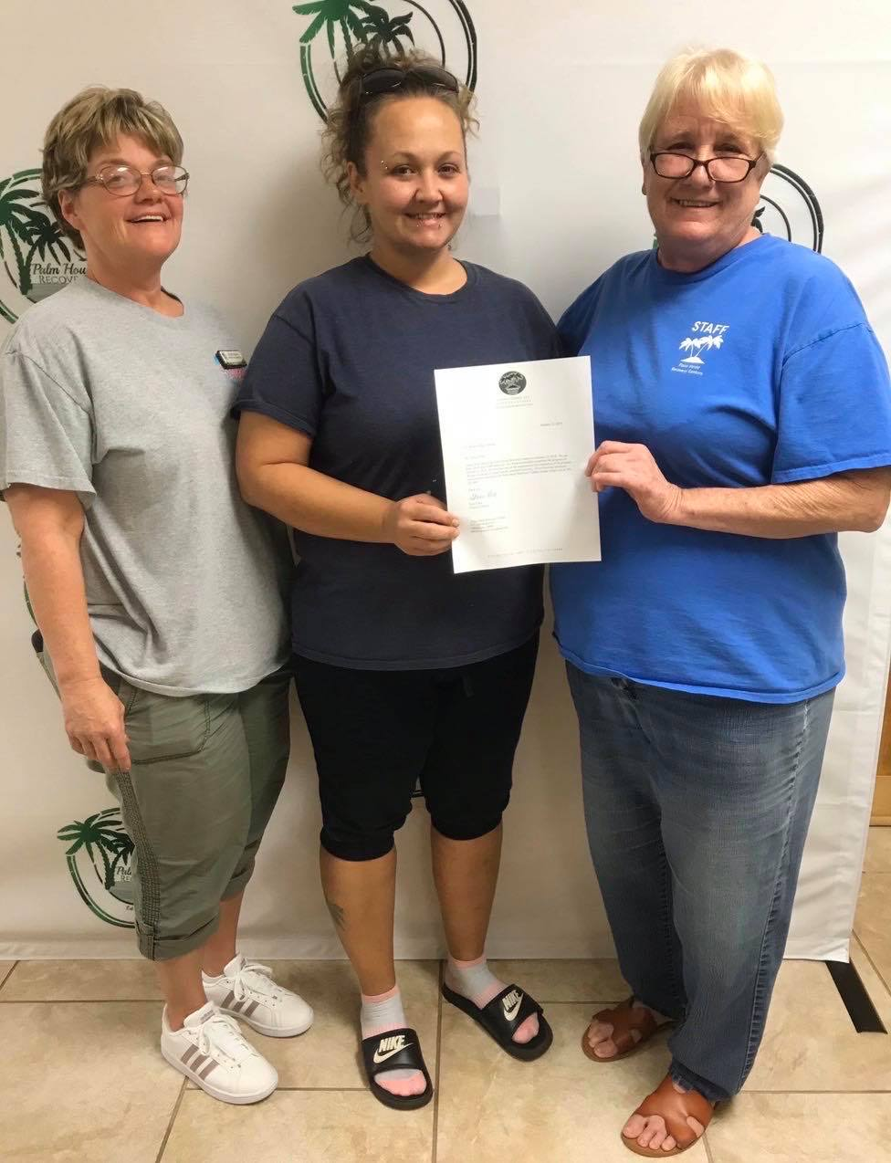
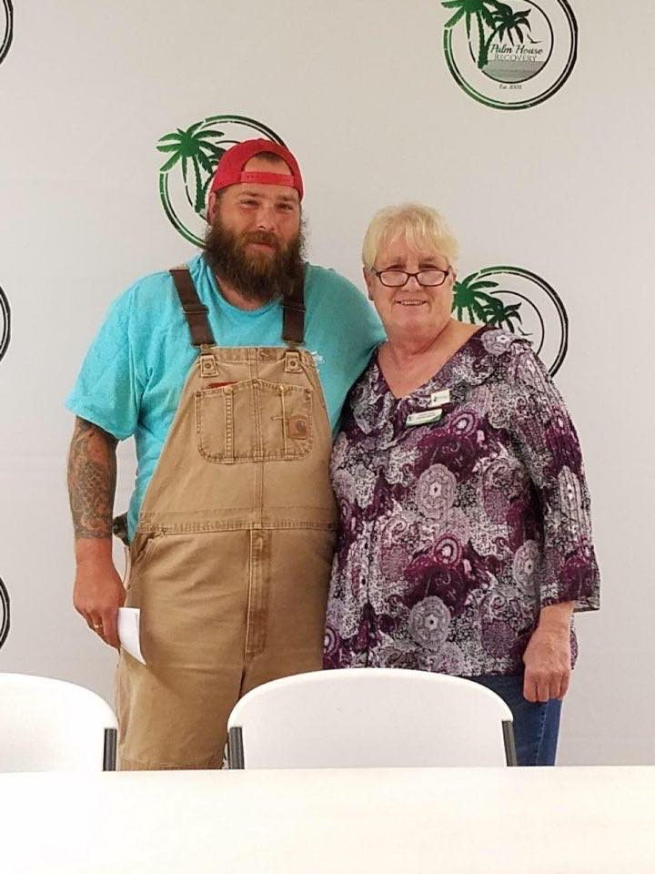
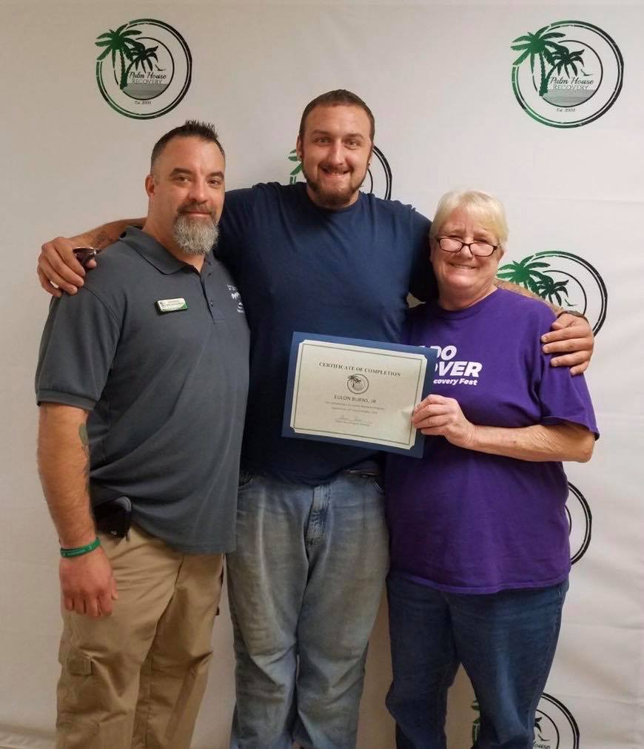
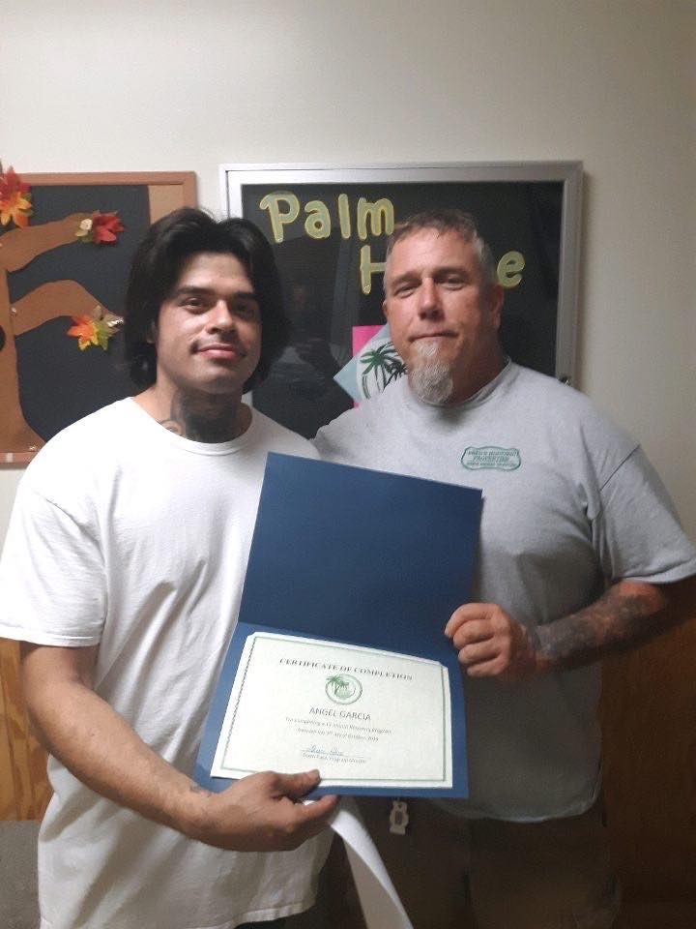
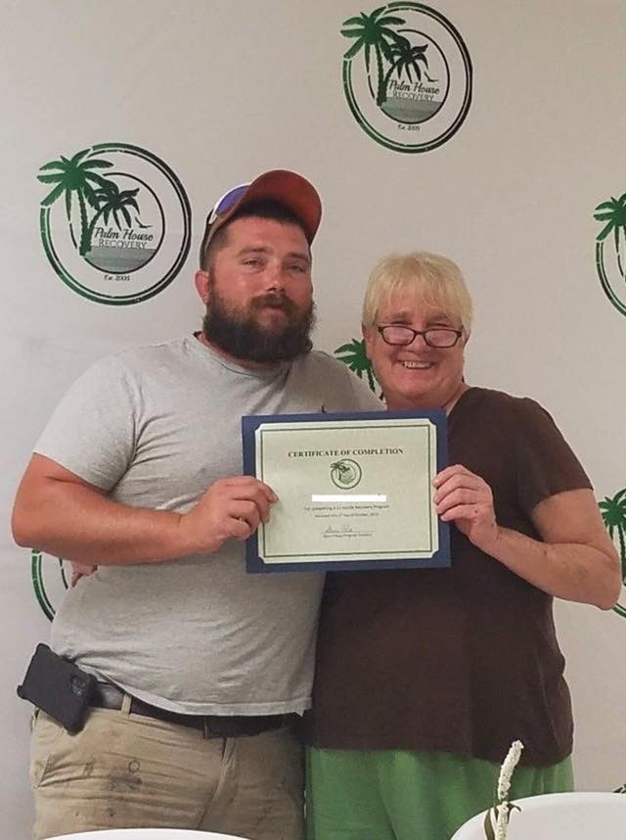
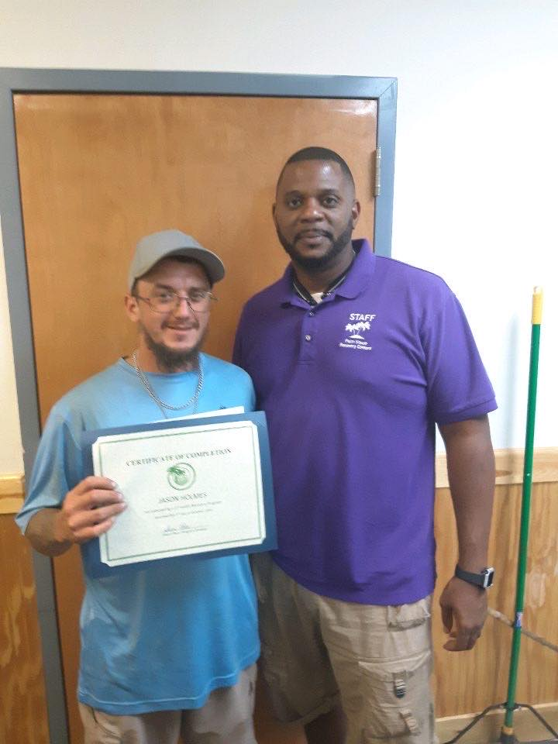
  - CONGRATULATIONS Josh, Amber, Thomas, Angel, EC, Adam & Jay!
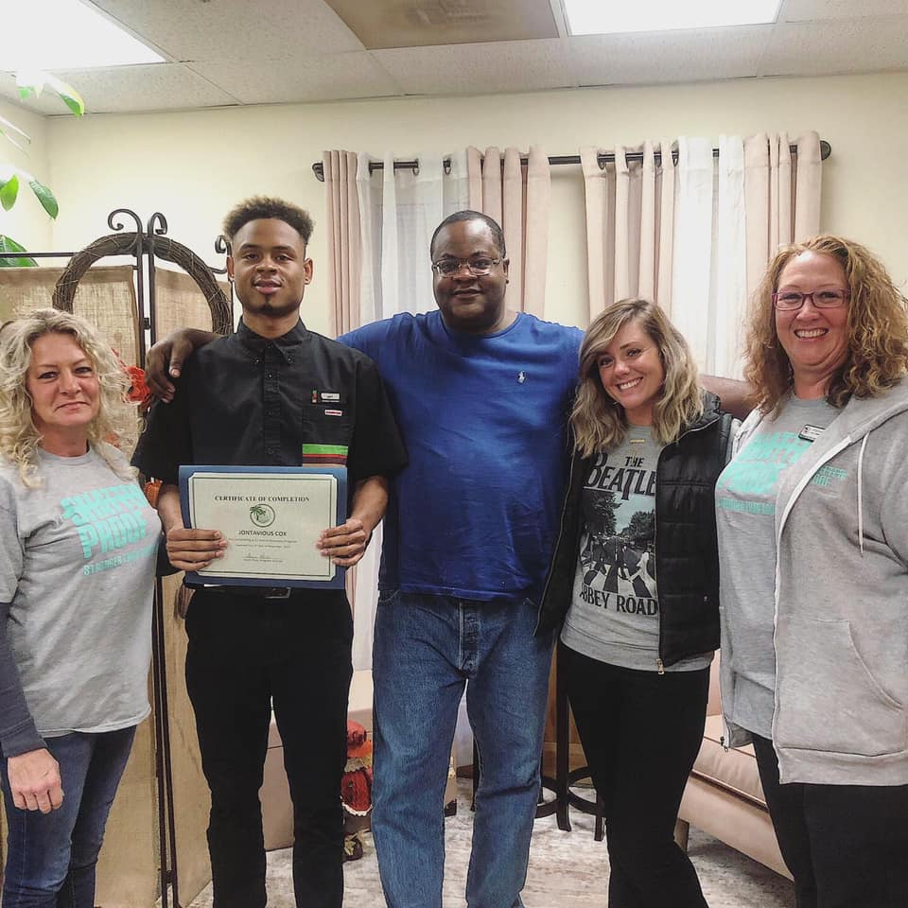
It’s that festive time of year again! Palm House Recovery Center’s Holiday Social is coming up! Come dressed in your favorite cozy pajamas (appropriately) for the chance to win a prize! We are looking forward to sharing a holiday meal together, enjoying some music and dancing & and making memories at the holiday photo booth!
Palm House Recovery Centers presents…
Holiday Social 2019
THURSDAY, DECEMBER 19, 2019 6:00PM TO 8:00PM
610 OGLETHORPE AVENUE, ATHENS, GA 30606
SEE EVERYONE THERE!!

Holiday Passes
- Residents here under 90 days will be allowed a day pass only (must qualify & submit pass request form)
- Residents here over 90 days may apply for a pass for the following dates:
- Tuesday December 24th to Thursday December 26th
- Wednesday December 25th to Friday December 27th
- Friday December 27th to Sunday December 29th

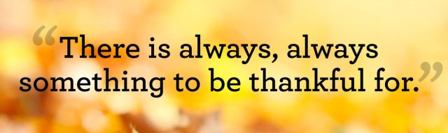
“No weekend passes are allowed for the first ninety (90) days. The resident must work at least 30 hours per week, residents paid bi-weekly must have 60 hours on their last paycheck stub, have met the weekly meeting requirements, paid their weekly fee, have a sponsor and have been paying consistently (at least four weeks) on their past due fees to be considered to take a weekend pass. Only two (2) weekend passes per month will be allowed and cannot be taken consecutively. ” - PH Resident Handbook 2019
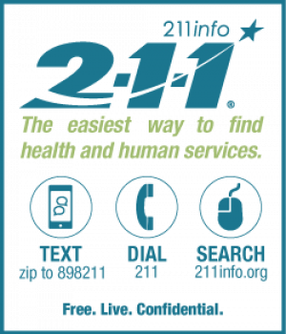
The United Way 211 line is a direct connection between those in need and those with the resources to meet that need by connecting individuals or families with the right agency that can help the most, as soon as possible.
United Way’s 211 is free, confidential, and available 24 hours a day, 365 days a year, in 140 different languages. We connect those in need to real trained professionals who are here to help.

a letter from our alumni meredith c.….
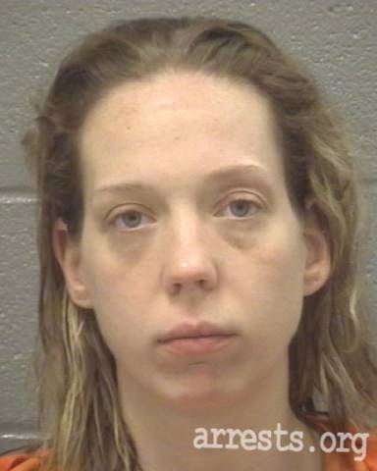
Hi my name is Meredith! I came to the Palm House on July 28, 2014. I had just graduated from a 6 week program where my counselor and I had talked about going to a long-term program if I was serious about staying clean. I was serious about staying clean and still am. I did not ever want to go back to the way I was living; couch surfing and living for that next fix. I had lost my kids, license, self-respect, and myself.
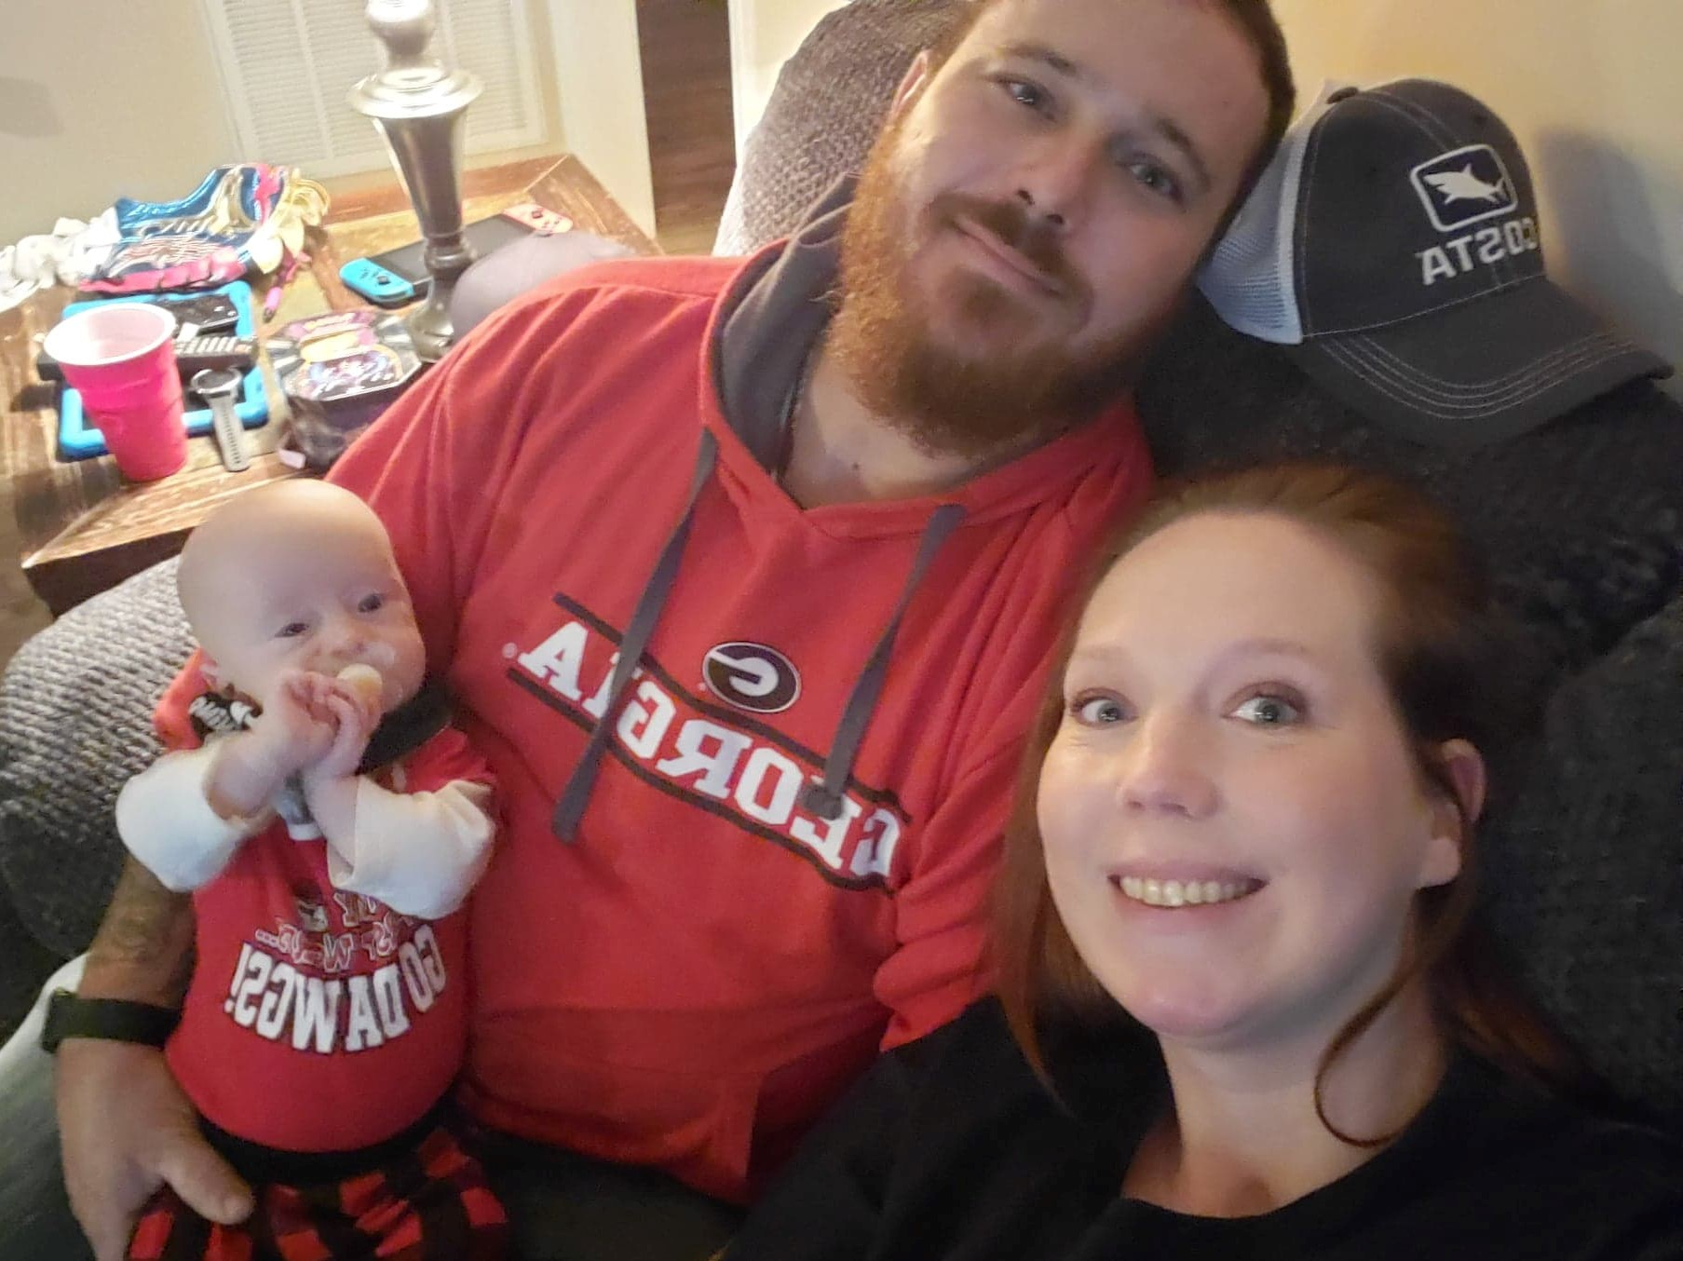
When I came to the Palm House, I jumped into the program with both feet. I hit meetings, got a sponsor, and started working steps. I did whatever was suggested to do! Eventually I became a house parent and completed the program. I decided to stay under the umbrella until last year when I got married and we bought a house.
I have been off probation now for 3 years, I got my license back and bought a car, and I’ve had the same job for 3 ½ years. I have a sponsor, and I sponsor other women in NA. My husband and I just welcomed our son into our family!
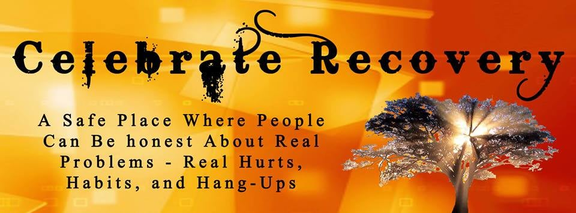
I would have never thought this is where I would be 5 years after coming into the Palm House. It works if you work it!
It is official!! Beginning January 2020 there will be an open Celebrate Recovery meeting on Saturdays at noon on the west side of Athens (and on the bus route) at Palm House Recovery Centers.
You are invited and will be very welcome!
Ministry Leaders: Stanton and Ariella Robertson
Stay tuned for details about a meet and greet at Thanksgiving and another at Christmas.
PALM HOUSE RECOVERY CENTERS, INC.
610 Oglethorpe Avenue, Suite B
Athens, Georgia 30606
(706) 543-0087 Phone
(706) 543-0088 Fax
www.palmhouserecovery.com
palmhouserecovery@gmail.com

